

# Ecological Survey – H 1550 (N) & (S)

*Nurture Ecology*

**Description of works:**

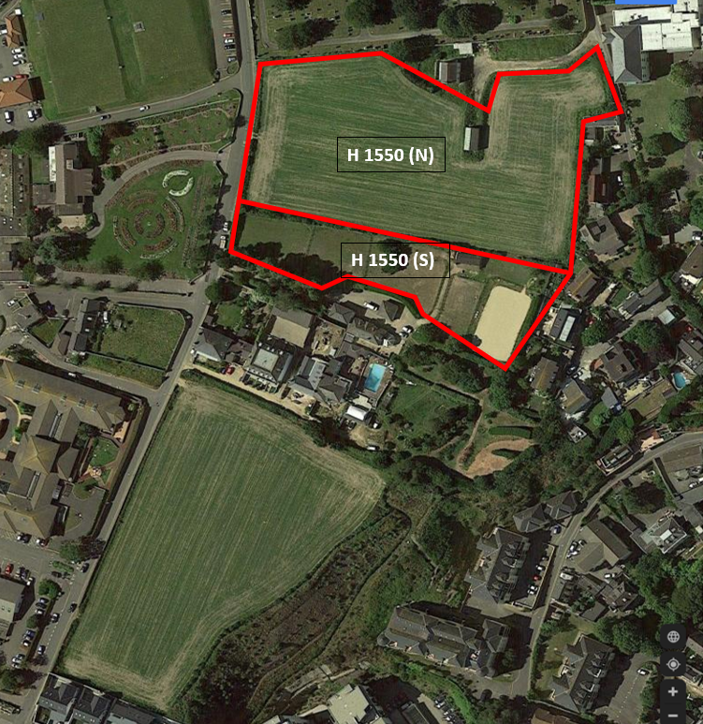We would like to carry out an ecological survey to assess and establish any environmental impact the proposed development of the hospital may have. The ecological survey will assess areas within the red boundary line showing in Fig. 01 and will encompass any considerations of ecological constraints that may become apparent from the output of the survey. The aim is to assess field H 1550 (N) & (S) for valuable plants, habitats and animals to measure any adverse effects the development will have on the wildlife over two stages. The initial stage is a desktop review of the area gathering information on any potential areas of interest, the next stage is with on-site equipment to record and collect data over the course of several weeks. The survey will also serve to understand and minimise disturbance on the immediate environment and provide a brief for the protection of endangered species that may be present.

Fig. 01

**Duration:**

The duration of the survey in H 1550 (N) & (S) will take approx. 9 weeks.

The proposed survey working times are between 08:00AM and 17:00PM Monday to Friday.

No works will be undertaken on Saturdays and Sundays

ROKFCC have already alerted the neighbours to the survey works and they will continue to keep all parties involved informed throughout the process and do everything they can to minimise disruption.

**Number of personnel:**

There will be 2 nr. personnel from nurture Ecology attending.